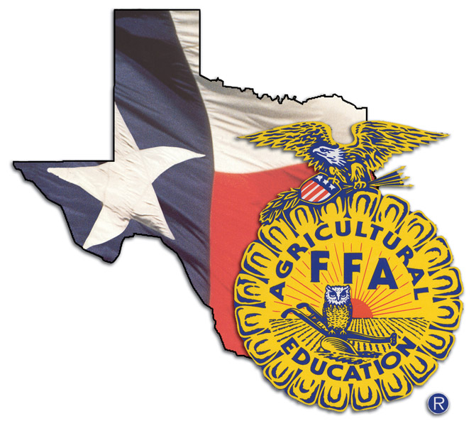
Bruceville-Eddy
High School
Course Syllabus

Course Title: Wildlife, Fisheries, and Ecology Management
Teacher: Mrs. TaLisa Ferguson
Email: talisa.ferguson@beisd.net

Course Description:
Wildlife, Fisheries, and Ecology Management examines the management of game and non-game wildlife species, fish, and aquacrops and their ecological needs as related to current agricultural practices.

Materials:
Three ringed binder
Notebook or paper in binder
Pen or Pencil

Class Rules and Expectations:
- All students will be seated with materials before the tardy bell rings.
- No food, candy, gum, or drinks (except bottled water) are allowed.
- Students will be respectful, at all times, of their fellow students, teachers, and school staff. Disrespect towards another will NOT be tolerated.
- Written or spoken profanity will NOT be permitted.
- Cell phone use is NOT permitted unless it is being used for instructional use.
- Follow all the rules established in the “Student Code of Conduct”.

Homework Policy: Homework will only be given in the event that the student wastes class time given to complete the assignment.

Late Work Policy: Students will be given at least one opportunity to submit late work (that is not related to an absence) for a maximum grade of 80. If a student is absent from class they will be given a day for each day they are out to turn in missed work.

Grading Policy:
Minor Grades (class work, quizzes, etc.) 60% grade weight (minimum 1 per week)
Major Grades (tests, projects, etc.) 40% grade weight (minimum 2 per six weeks

Course: Wildlife, Fisheries, and Ecology Management
Period: ________

I have read and agree to follow the course syllabus for this course. Please return to Mrs. Ferguson by the end of the first week of school.

________________________
Student Printed Name

________________________ ________________
Student Signature Date

________________________ _________________
Parent/ Guardian Signature Date

